**Intro to android**

Android is linux based operating system which is designed for the smartphones, tablets,etc.

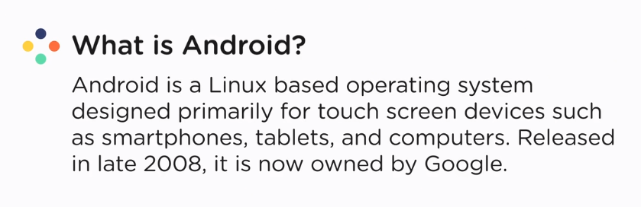

It is developed by Android Inc. and later owned by google in 2008.

Every year, android releases its new version. Latest is android 9 - pie.

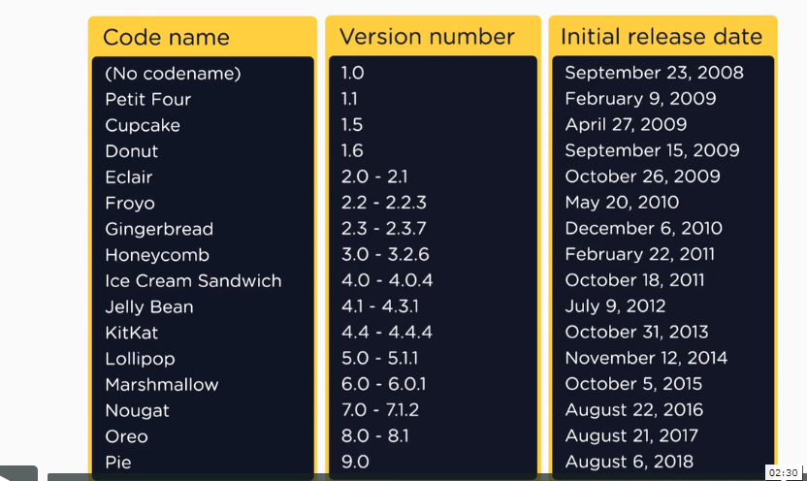

Google play store – it is marketplace for the android applications. All the android developers post their apps on google play store so that users can download and then, install them on their devices to use them.

Android app - it is a software application that runs on the android platform like whatsapp, fb, Instagram,etc.

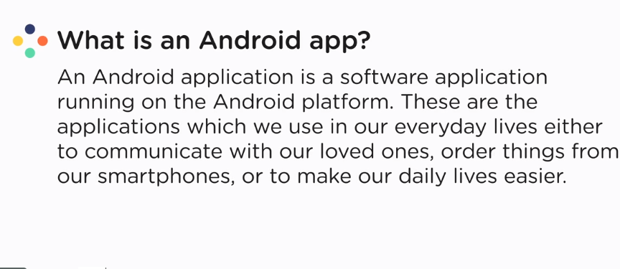

Components

Front end – UI , xml

Backend – logic,functionality – java,kotlin , c++

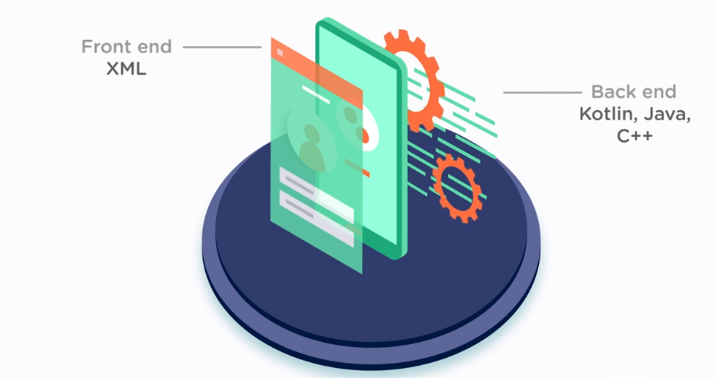

Native android apps – web apps

XML – it stands for extensible markup language which defines the structure of the data.

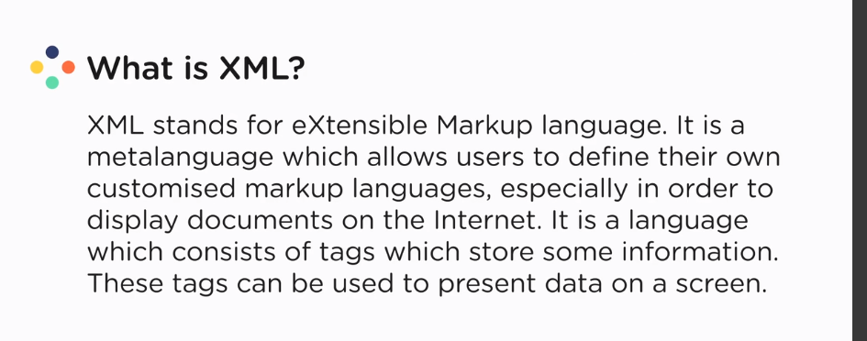

Kotlin – static typed language , fundamental language for android apps

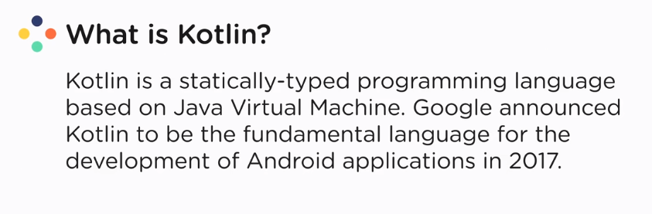

IDE – environment for proper development.. has debugger, compiler,etc.

Android studio

IDE for development of android apps

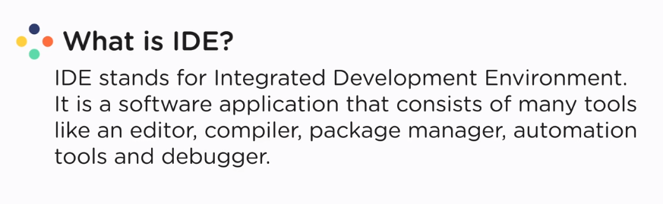

By intellij

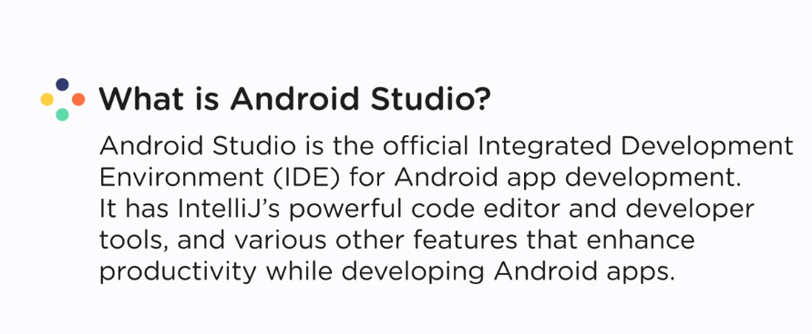

Software development kit – sdk

Has collection of libraries that are used to develop android apps

Mandatory for every development , jdk for java,,,,

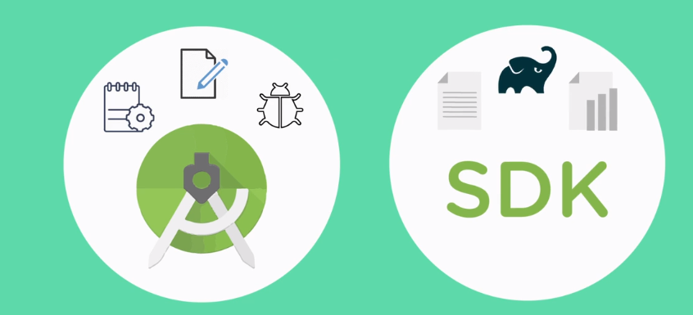



Xml –

Tag – something that has data and its formatting and used to represent data on screen.

<tag attributes=””> jgavdfa </tag>

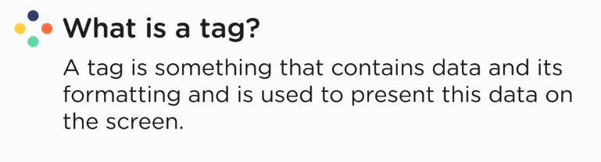

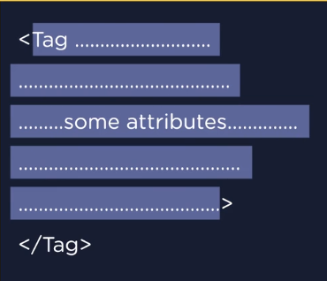

Kotlin

Fun is a keyword.

fun main(){

}

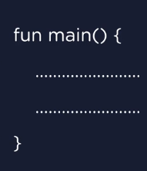

**World of kotlin**

Fundamental language to develop apps

History

* Android is owned by google in 2008.
* Developers uses java or c++ for developing apps.
* C++ for complex code
* Java has its own cons :
  + Syntax – large code for short feature, like only printing a line
  + Boilerplate code – redundant code
* Google provide sdk for developing apps for IDE like intellij idea or eclipse
* Google decided to have an IDE for spefically only for android app s, it contact intellij
* In 2012 , andoird studio came
* In 2013 ,studio is undamental ide for apps
* Jetbrains decided to propose a new language to overcome java problem
  + 2016 – 1st stable version of kotlin
  + 2017 – fundamental language of developing android apps
* Kotlin is interoperable with java

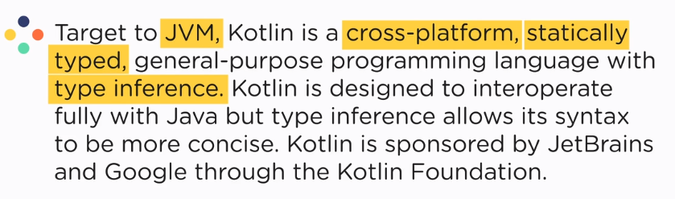

JVM – environment for the execution of the java or kotlin bytecode

Java Compiler converts the source code into bytecode

Cross platform

Static type language

It detects the type of variable at the compile time

A variable cannot have more than one type values throughout the program

Type inference

It detects automatically the type of the variable

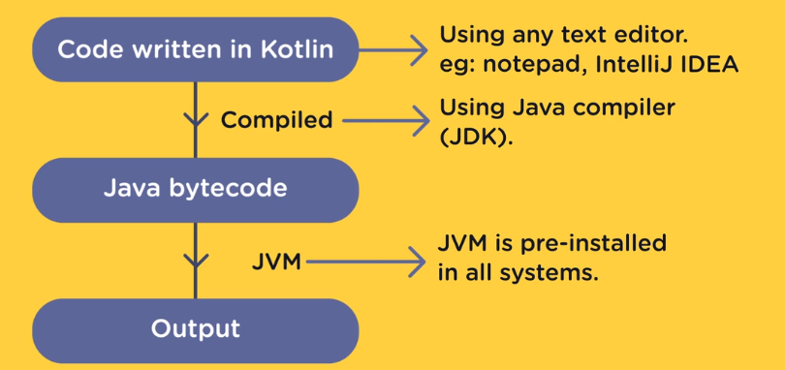

Main() – always should present in file as it is starting point for the compiler

It is automatically called by IDE

println() – used to print text and then moved to next line

print() – used to print text and then stayed on same line

variables – containers that store data in them which can we use in future

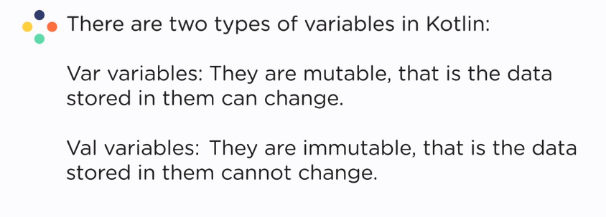

Identifiers – names to identify the variable or container

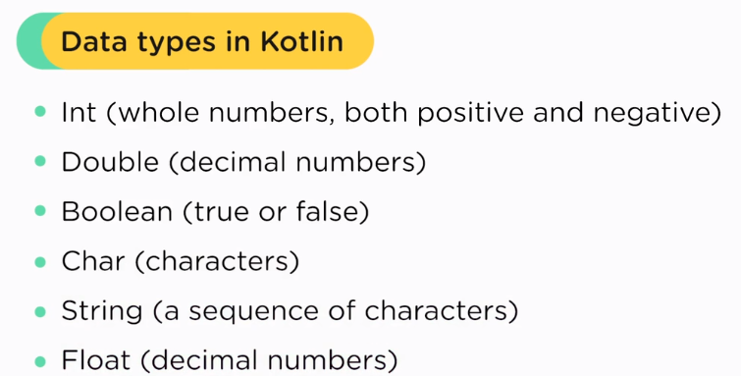

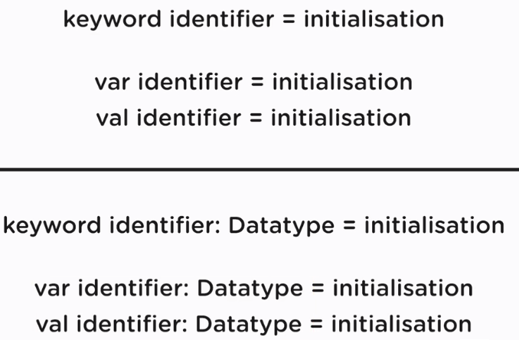

we give data type to the variable bcoz sometimes we don’t initialize while decalring them

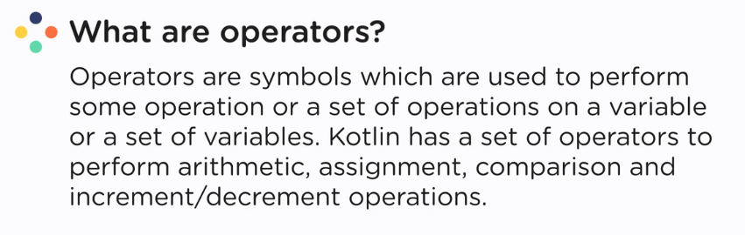

Operators – symbols used to perform operations

* arithmetic
* comparison
* assignment
* increment / decrement
* logical operators

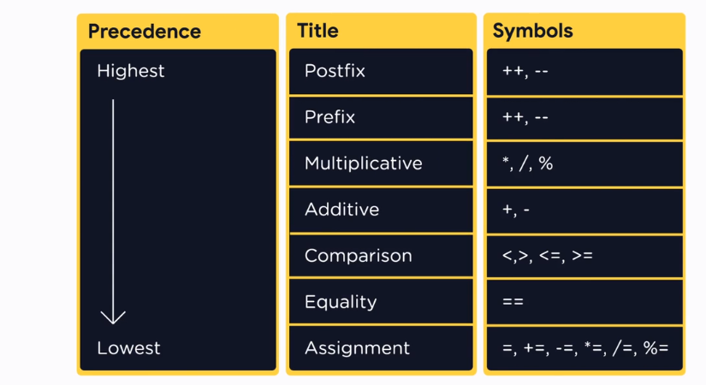

Strings

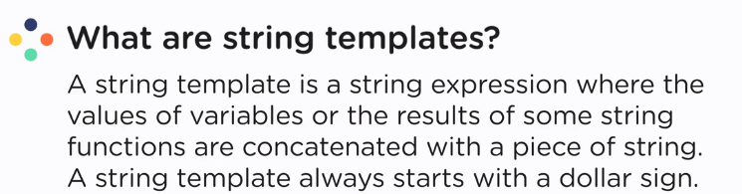

Use $ to concatenate the strings and curly braces for function.

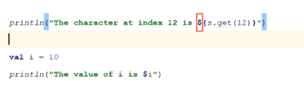

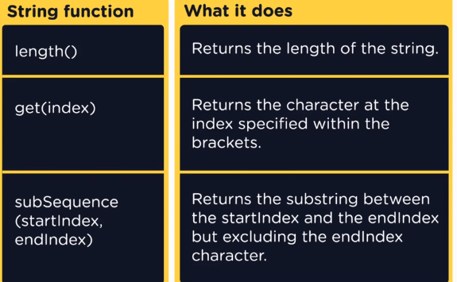

Functions

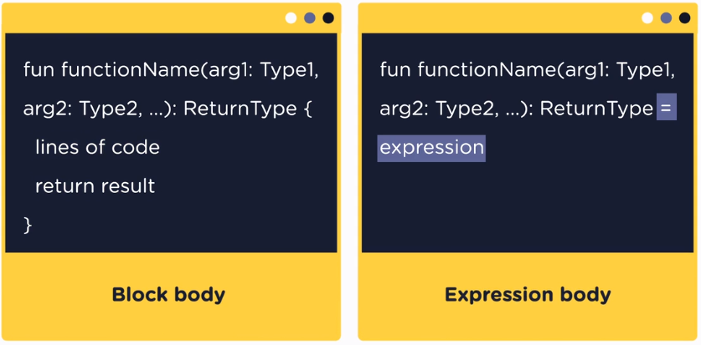

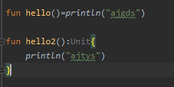



The size of array cannot change.

For var array , we can change one,more or all elements at a time or we can do a=b

For val array , we can change one or more but not all elements at a time and we also cannot for a=b.

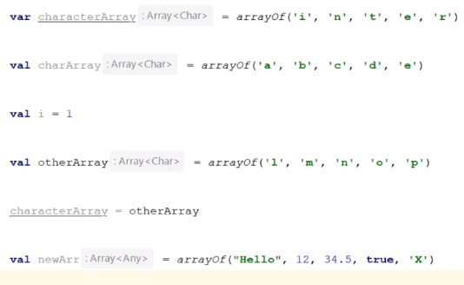

Select case

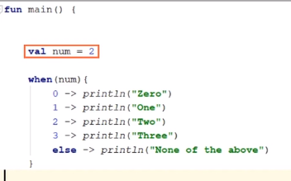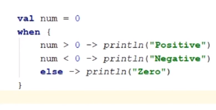

Range check

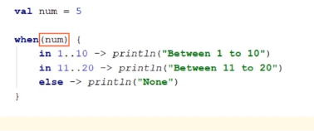

Loops

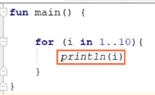 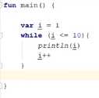 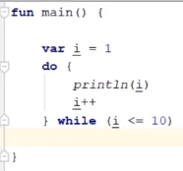

Increment in loops

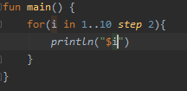 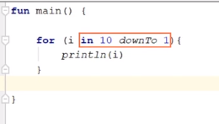

Lists

* Immutable list – neither size can change nor elements listOf()
* Mutable list – elements and size both can change mutableListOf()
* Array list – same as mutable arrayListOf()

Error and exceptions

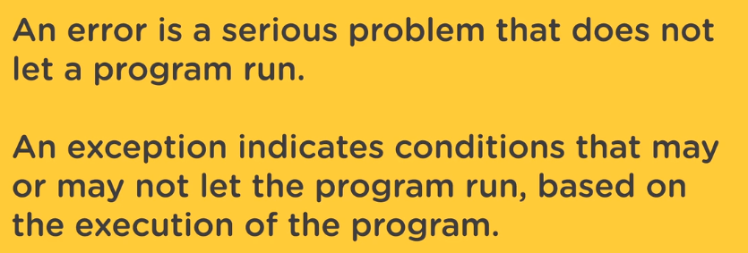

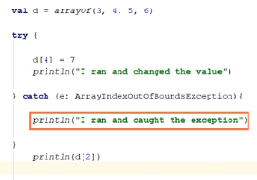

Null pointer

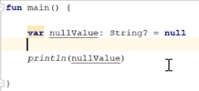

For null variables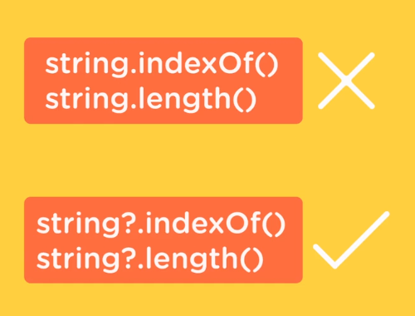

Elvis operator :- 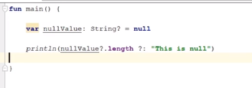

Filter null values



Objects and classes

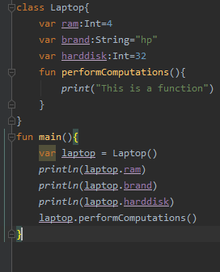

Constructors

* Primary constructor

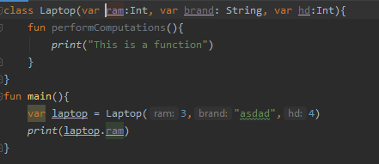

* Secondary constructor

With only secondary constructor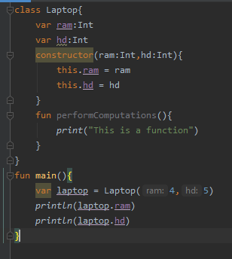

With primary and secondary constructor both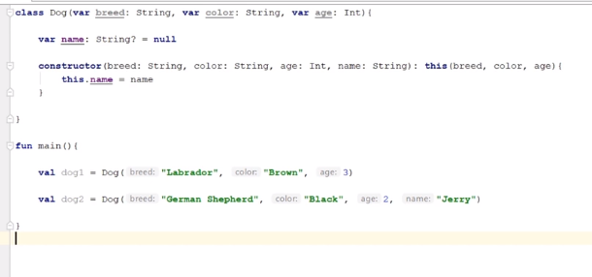

To access the data passed to the variables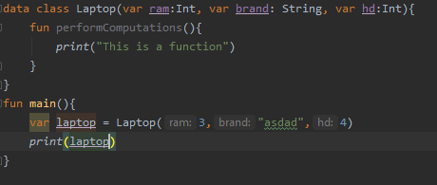

They can be used to compare two objects data

Inheritance

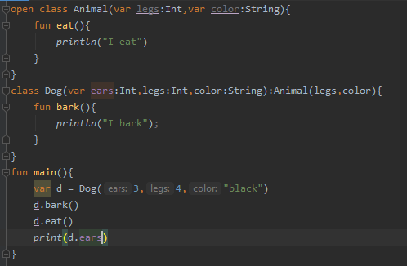

Open – add it to everything that needs to be modified, class or function

Override e- to override the function

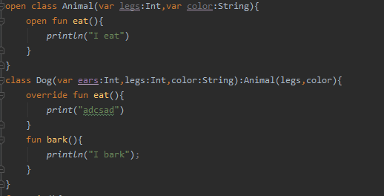

**Visibility modifiers**

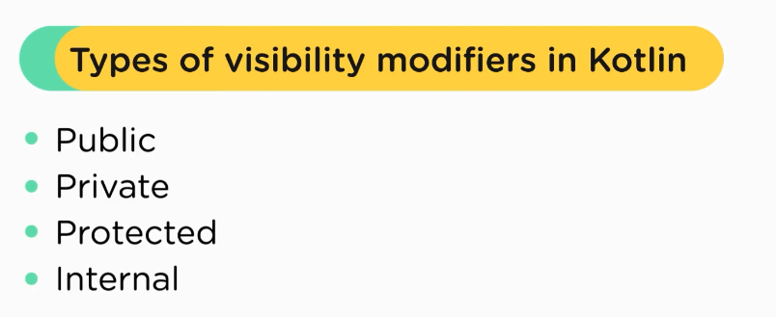

Scope:

Public > internal > private > protected

Interfaces

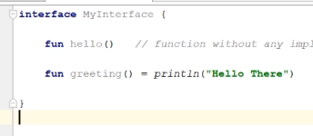

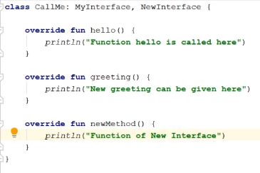

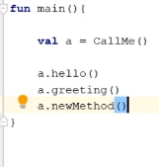

MODULE 3

Androidmanifest.xml : it is a file that represents or provide all the info about the app to the android OS.

* Xmlns : provide the xml namespace for android features
* Application tag : provide the info related to app like label,icon,etc.
* Activity : provide the files that include the actual functionality of the app
* MAIN : provide the start of the app
* LAUNCHER : provides the screen at the time of launching

Java folder : contains the whole kotlin code

Res folder : contains all the resources that are needed like layout , images,etc.

* Drawable : images, design files
* Layout : layout files
* Mipmap : contain the app launcher icon
* Values : values that are used in app

Gradle scripts :

* Build.gradle : gradle build the packages that are needed to build app

Acitivity

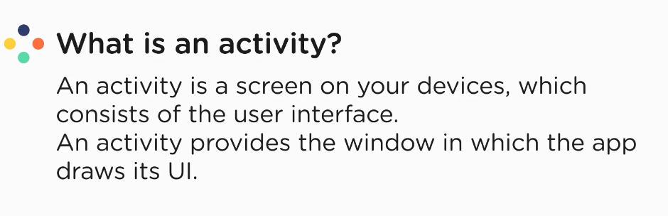

Different screens , different activities

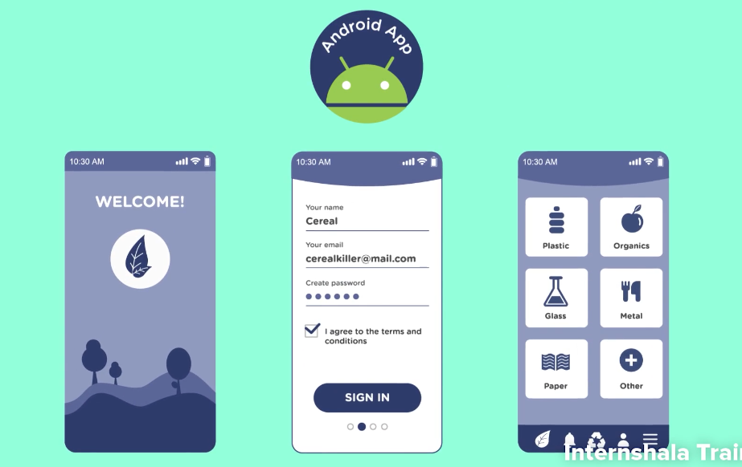

The first screen is called the main activity.

When only the content changes on the screen but not functionality, that’s not an activity. Example :

* Traversing through different profile in insta is considered as one activity
* Watching a profile and their stories considered as different activities.

Activity lifecycle : it is a series of states in which the activity transit from one state to another. In activity , we define methods called callbacks , which defines the code to execute for the event that occur.

* onCreate() : every activity have this method.. it has the startup logic of the ectivity. It calls onStart() and onResume()
* onStart() : it makes activity visible to user but not interactive with user
* onResume() : it is called when activity is ready to interact with user. The activity leaves this state only in case of interruptions like moving to other app, call came,etc.
* onPause() : when it goes into background or it loses its focus. Resources got free. This state only changes in two events:
  + when it got resumed : onResume().. in this case the instance got saved where we left off
  + when it got completely invisible : onStop()
* onStop() : when an activity is longer visisble to user
  + when a new app takes all the screen
  + when the system needs more resources than it have, it keeps the background apps to onStop() rather than onPause() state like we are on a call for an hour , all other apps go to to onPause() state for a while and then to onStop()
* onDestroy() : this is the last call to the activity.
  + It can be called by user or by the system in the cases where the app got hanged
* onRestart() : when the app returned to active state

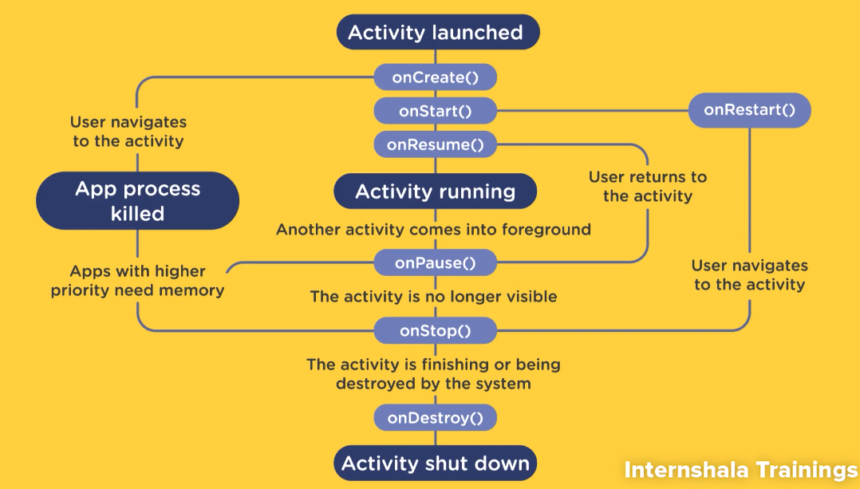

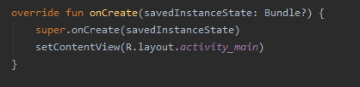

onSaveInstanceState() – that is needed to override the saved instance. these instances are saved in bundles therefore their data type is bundle.

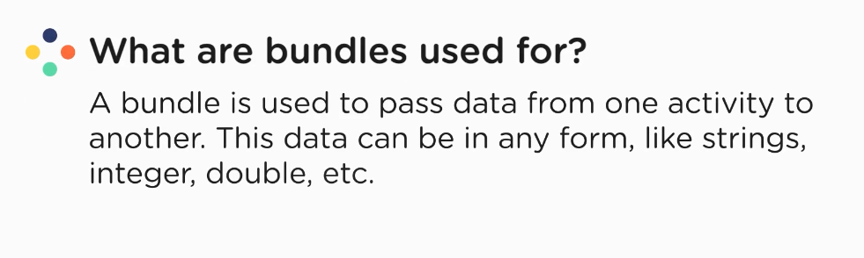

Super.onCreate() : it refers to the default implementation of onCreate() method defined in AppCompactActivity() file.

R : auto-generated file in android

* + whenever we add any resources to res directory , it got a unique id to access it. These id are stored in R file.
  + And then , R file is used to access these resources.

R.layout.activity_main : it is used to access the activity_maian file in the layout directory.

Activity_main : it is file which stores the UI of the activity.

setContentView : it sets the layout on the screen.

Logcat window

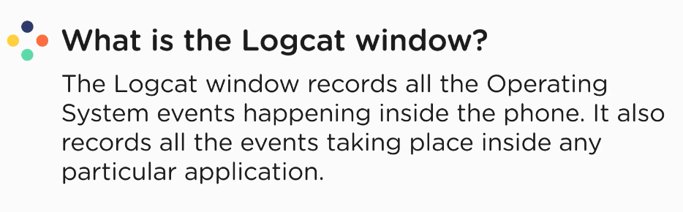

Androidx.ConstraintLayout : It adds constraint to the child tags and how they will be aligned.

View and viewGroup

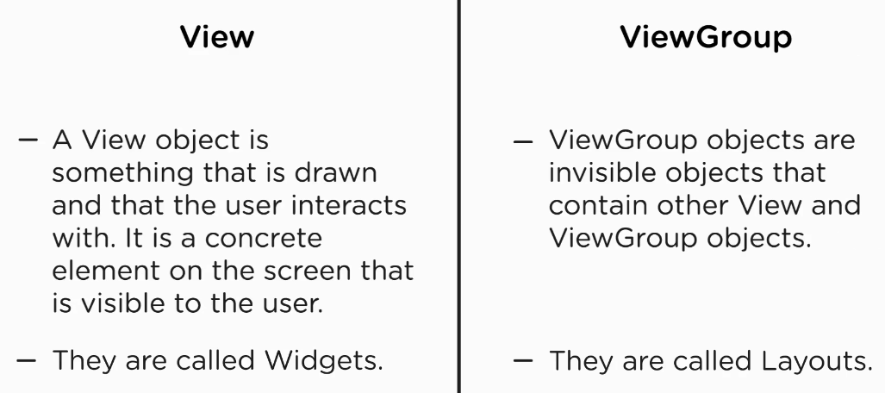

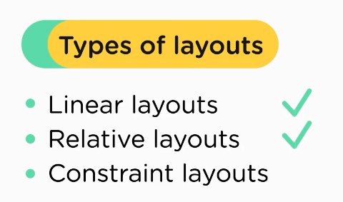

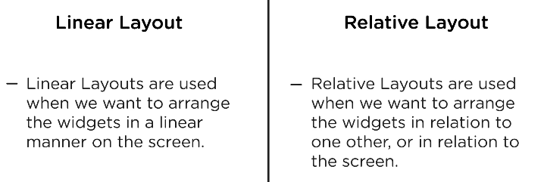

Pixel: lowest unit to represent data on screen

Pixel density: number of pixels per unit of screen

More density > better quality

dp -> density independent pixels

sp -> scalable pixels : for data change accordingly to the screen size

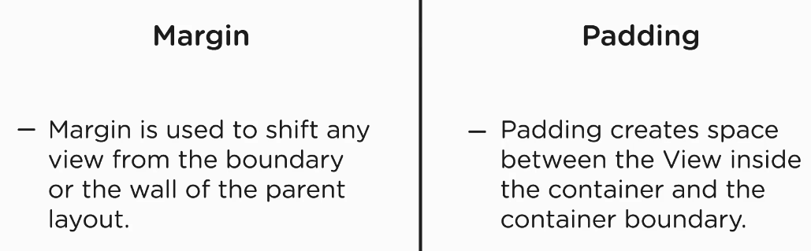

<https://material-ui.com/customization/color/>

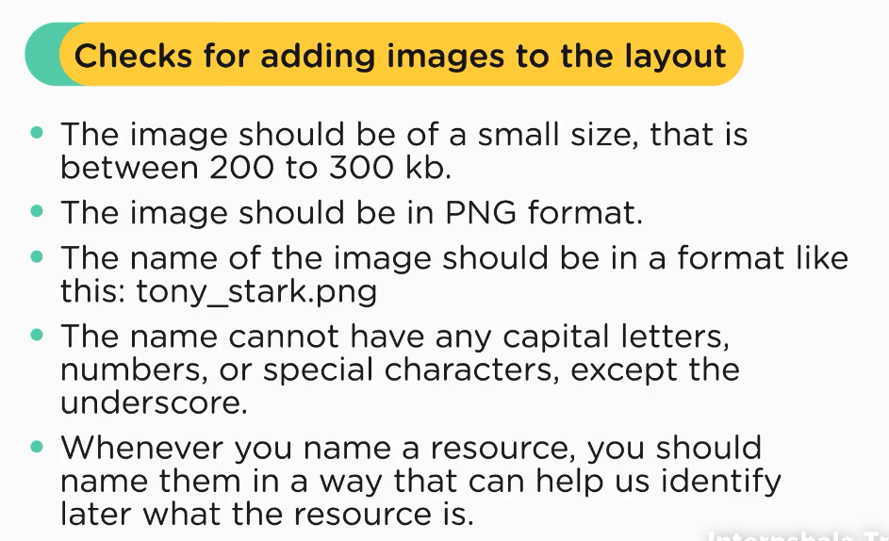

* adding text

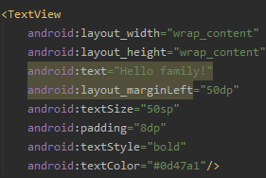

* adding image

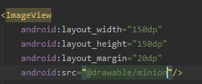

* input

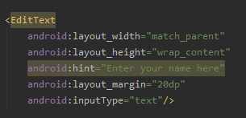

**Relative layout**

Create relative layout by clicking the layout folder and then , layout file.

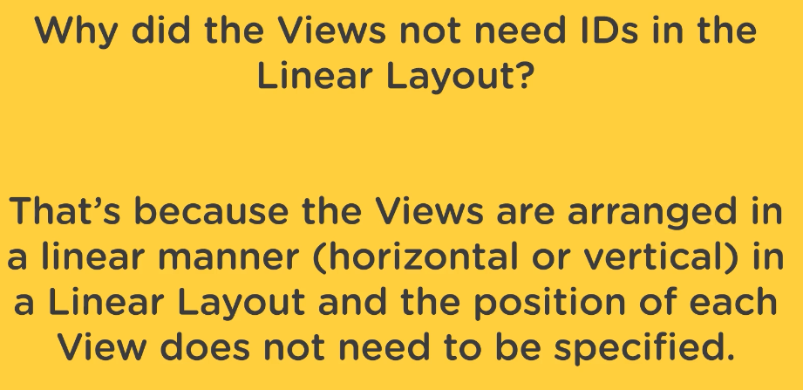

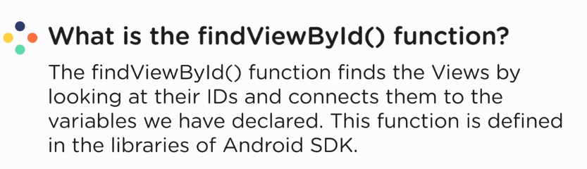

Onclick listener

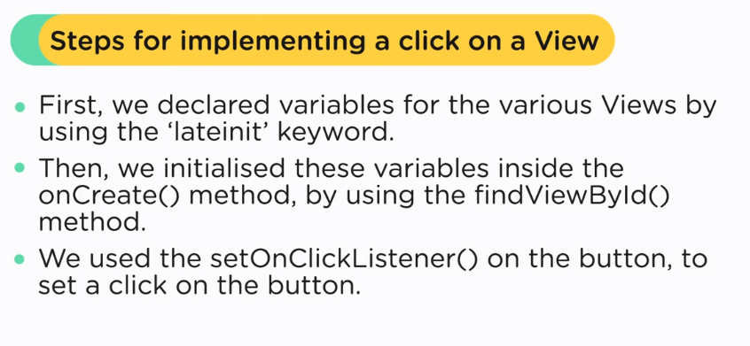

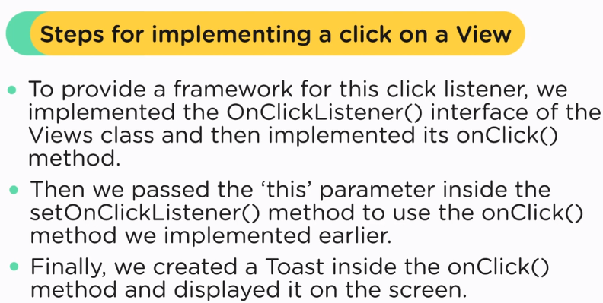

Intent

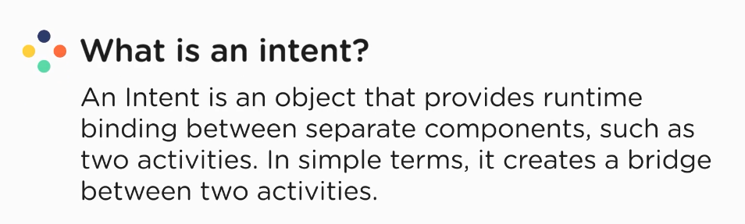

SharedPreferences: a file that stores data on the users device…. Stores data in key value pair

There are two ways to store data :

* database
* sharedPreference

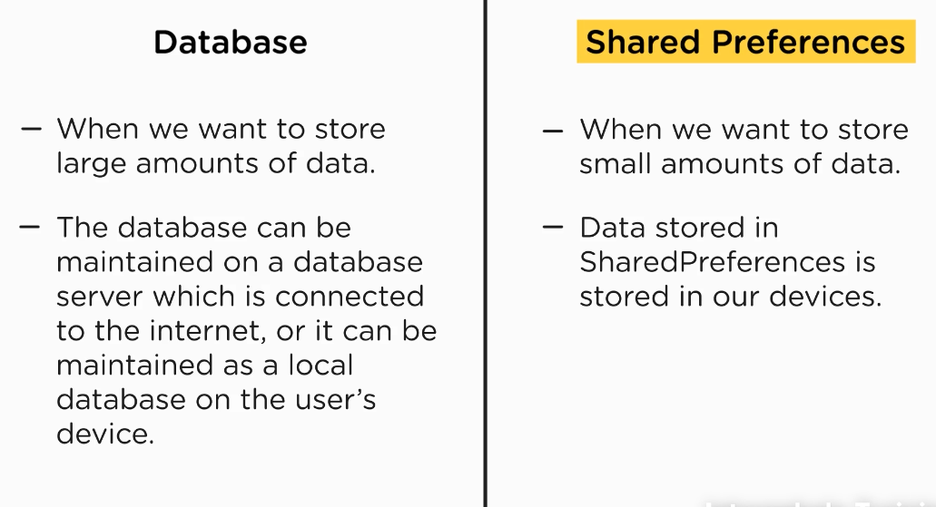

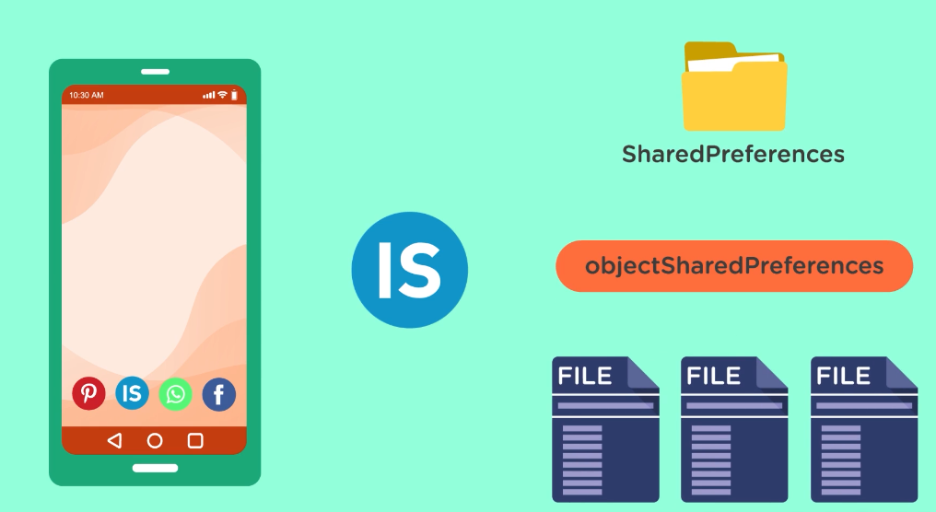

Read data from sharedPreference:

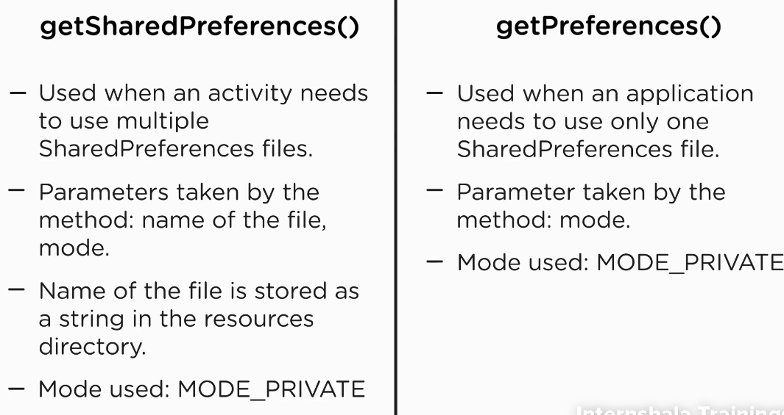

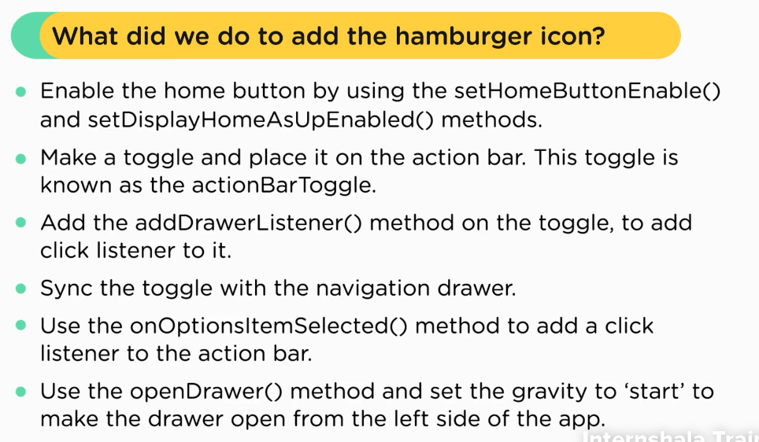

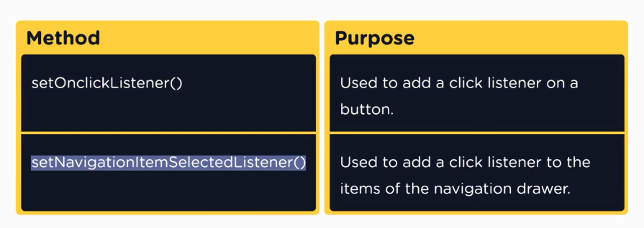

Fragments

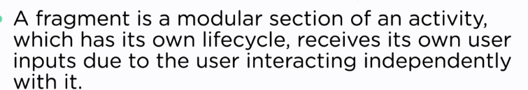

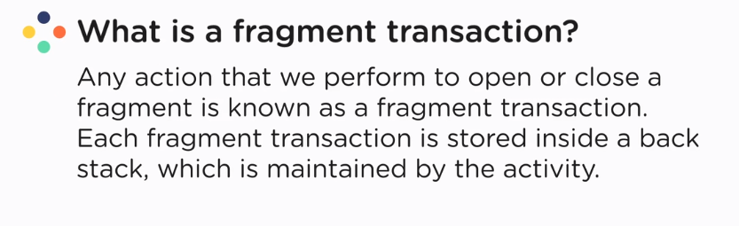

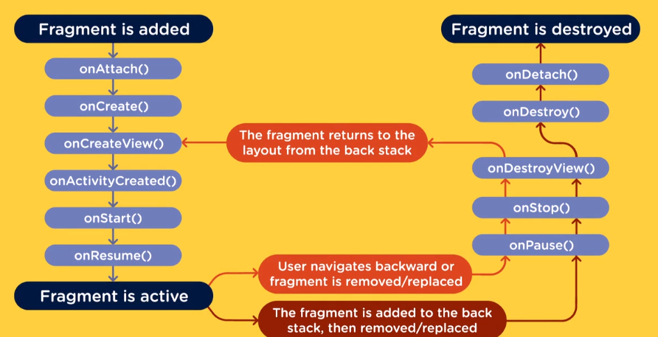

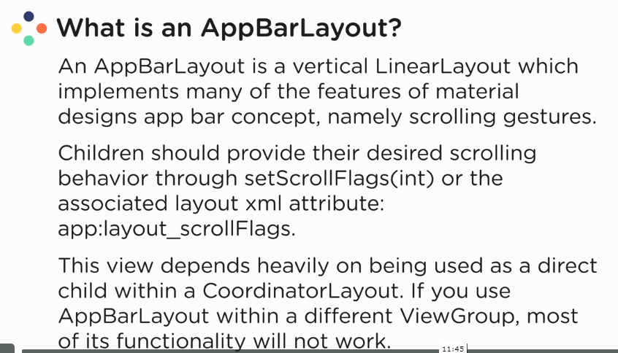

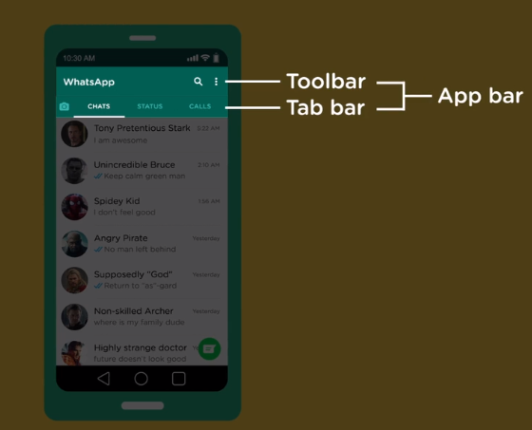

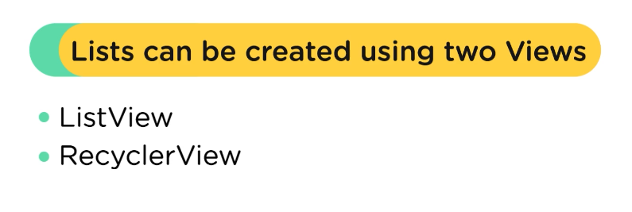

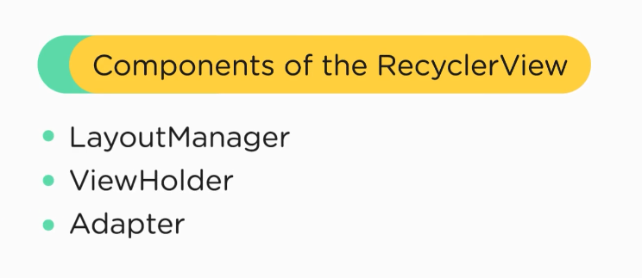

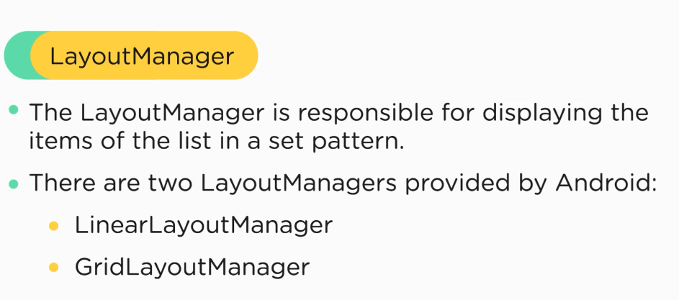

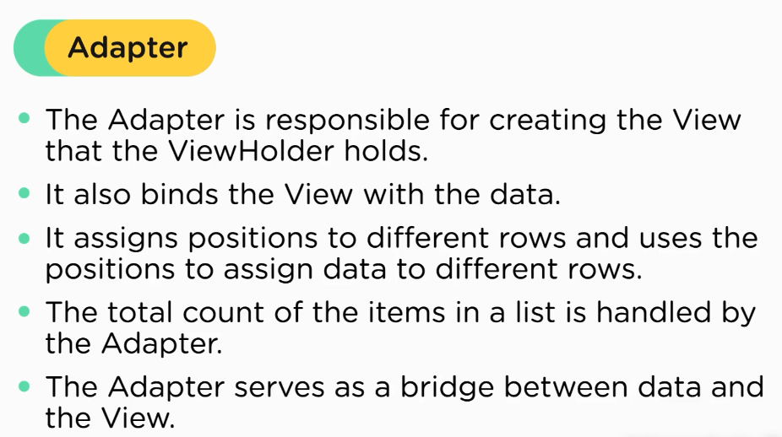

Viewholder : it hold the views in which the data is represented

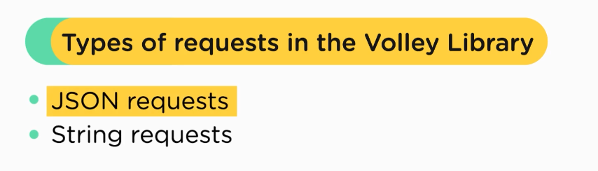

JSON request

* json array
* json object

